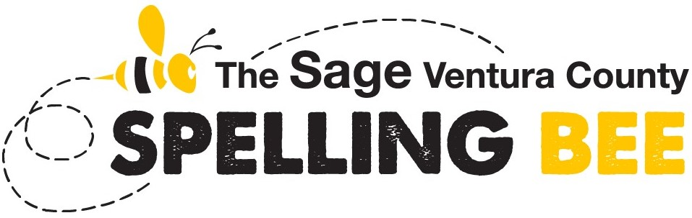
PRELIMINARIES
Testing Window
Monday, February 9 through
Friday, February 13, 2026
[This is a VIRTUAL event]
All School Spelling Bee Champions will participate in this virtual event. The Preliminaries are hosted on the Scripps’ Online Testing Platform (OTP).
The top 15 to 20 highest scoring spellers from the Preliminaries will advance to the Final Oral Rounds of the 2026 Sage Ventura County Spelling Bee.
TEST FORMAT
This test is a 30-minute, 50-word test that may be taken at any time during the testing window. This test is a combination of 25 spelling words (type in the spelling) and 25 vocabulary words (multiple choice). Five of the 25 spelling words and five of the 25 vocabulary words (10 words total) do not appear on any study list and come from the official dictionary, Merriam-Webster Unabridged. The remaining words come from the 2026 Words of the Champions.
IMPORTANT
- How to study for the Preliminaries? The 2026 Words of the Champions is the official study list of the 2026 Sage Ventura County Spelling Bee. The speller should study all three difficulty levels — “one bee,” “two bee” and “three bee.” For more information about this list and how to obtain a copy, please visit Official Study Resources.
- Where to take the test? This virtual test must be taken in a school environment and proctored by the school’s spelling bee coordinator or their designee. Please coordinate with your school’s spelling bee coordinator, teacher, or principal. See “Mandatory Integrity Protocols,” below.
- Equipment needed for the Online Testing Platform – Spellers can take the online test on any device with a web browser. The OTP supports the following browsers: Chrome, Firefox, and Edge. The OTP will not work on devices running Safari for Desktop or Explorer.
- How to access the Online Testing Platform – A special invitation with a link to access the OTP will be emailed to each speller by Wednesday, February 4, 2026.
- Do not begin this test until you are prepared to finish it. Although spellers will have the opportunity to review their test answers within the 30-minute test window and prior to submission, they will not have the opportunity to stop and start the test.
- Mandatory Integrity Protocols are in place to ensure an equal testing platform for our spellers. We use a three-pronged approach to testing integrity: a time limit that curtails the use of external sources; a Bee Integrity Pledge that must be acknowledged prior to taking the test; and we require that the test be taken in a school environment and that your school’s spelling bee coordinator (or their designee) serve as a proctor/monitor and be in the room while the test is being taken. If this last protocol can’t be supported by the speller’s school, please reach out to Julie Lopez at vcspellingbee@sagepub.com or (219) 688-3168 as soon as possible.
- Do not share any questions/words from this test at any time during the testing window (Monday, February 9 through Friday, February 13, 2026).

