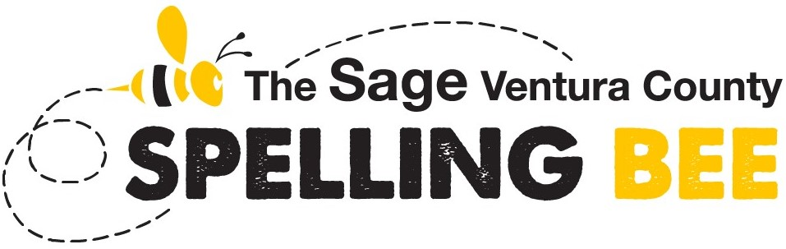
FINAL ORAL ROUNDS
Saturday, March 7, 2026
10:00 a.m. to no later than 4:30 p.m.
[This is an IN-PERSON event]
Ventura County Office of Education
Conference & Educational Services Center
5100 Adolfo Road, Camarillo, CA 93012
Map & Directions
The top 15 to 20 highest scoring spellers from the Preliminaries will advance to the Final Oral Rounds of the Sage Ventura County Spelling Bee. Lunch is provided.
TIMELINE
10:00 a.m. Speller check-in and activities
11:00 a.m. Introductions
11:15 a.m. Lunch for spellers and pre-registered guests
11:40 a.m. Announcements
11:45 a.m. Spellers report to chairs
12:00 p.m. Announcements
12:15 p.m. Competition begins
3:45 p.m. Hard stop in competition with institution of a tiebreaker, if needed
4:30 p.m. Competition ends … if not before this time.
FORMAT
This Bee will include spelling and vocabulary rounds and, if necessary, a tiebreaker. The winner of this Bee will advance directly to the Scripps National Spelling Bee.
This Bee is governed by the 2026 Suggested Rules for Spelling Bees - no appeals published by the Scripps National Spelling Bee. Sage reserves the right to modify these rules based on the needs of the Bee.
Words for the Final Oral Rounds will come from the 2026 Regional Competition List designed by the Scripps National Spelling Bee specifically for use in conducting the 2026 Sage Ventura County Spelling Bee. This list will offer 350 words selected from the 2026 Words of the Champions, the official study resource for school spelling bee champions; 150 words selected from Merriam-Webster Unabridged online; and instructions, words, and materials for Sage to utilize in conducting a tiebreaker test, if necessary.
Typically, the initial rounds are spelling and vocabulary rounds using words from the 2026 Words of the Champions. Depending on the speller competition, subsequent rounds could contain words selected from Meriam-Webster Unabridged online.
For information about the 2026 Words of the Champions, please visit Official Study Resources.

